Mei Guo    “I love advancing my research in quantum mechanics, but balancing my Ph.D. work and being a mom can be overwhelming sometimes.”  AT A GLANCE  AGE: 29  LOCATION: Kelowna, BC  LIFE STAGE: Ph.D. student and mother  SITUATION: Graduate student in Mathematics, juggling research, teaching assistant work, and caring for her two-year-old child; lives with her partner near campus. | MOTIVATORS  - Academic success — Mei is driven to finish her Ph.D. and secure future research opportunities or a faculty position.  - Family — Spending meaningful time with her young family keeps her grounded, even amid the pressures of academic life.  - Professional relationships — She values maintaining good working relationships with professors and hopes to continue TA roles with preferred faculty.  BEHAVIOURS  - Carefully manages time — Mei balances research, coursework, TA duties, and family obligations, often scheduling tasks tightly.  - Applies selectively — She prioritizes TA applications that match her schedule and expertise to avoid overload.  - Stays organized — Mei relies on digital calendars, to-do lists, and clear systems to track commitments, especially near exam periods.  NEEDS  - A centralized system to view and manage TA applications and assignments  - The ability to highlight preferred TA assignments or professors  - A clear, non-repetitive application process that reduces back-and-forth emails  - Tools to help avoid scheduling conflicts, particularly during exams.

Ben Jackson  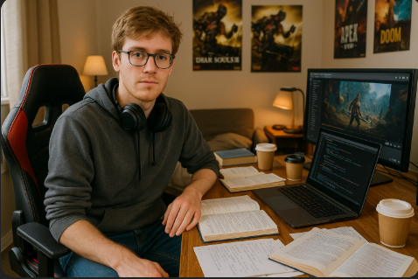  “I’m focused on wrapping up my degree and growing my streaming channel — finding a TA job helps me build experience and earn some extra money.”  AT A GLANCE  AGE: 20  LOCATION: Kelowna, BC  LIFE STAGE: Undergraduate student, side-hustle streamer  SITUATION: 3rd-year business student with a computer science minor; lives in shared student housing; balances academics, campus work, and Twitch streaming. | MOTIVATORS  - Resume building — Ben wants to enhance his resume with meaningful on-campus experience before graduation.  - Financial independence — He’s motivated to earn extra income through a TA role to support his hobbies and side projects.  - Growth mindset — He enjoys learning and explaining concepts to peers, making TA work a natural fit.  BEHAVIOURS  - Selective engagement — Ben focuses on applying for roles in courses he’s confident with to maximize success.  - Balances multiple priorities — He manages his time between classes, side-hustle streaming, and social life.  - Easily discouraged — Past bad experiences with clunky campus application systems make him hesitant to apply if the process feels too complicated.  NEEDS  - A straightforward, transparent application system for TA roles.  - Clear tracking of application status and deadlines.  - The ability to manage TA commitments alongside his class schedule and personal projects.

Fatma Ozturk  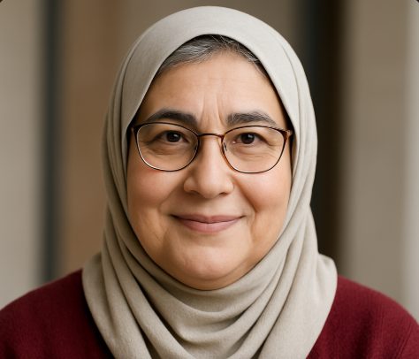  “I love mentoring students and bringing history to life in the classroom — but managing TA assignments for so many courses can get chaotic.”  AT A GLANCE  AGE: 60  LOCATION: Kelowna, BC  LIFE STAGE: Experienced lecturer and published author  SITUATION: Faculty member in Arts and Social Sciences, teaches multiple classes each semester; enjoys strong student relationships; relies on family help to navigate new technologies. | MOTIVATORS  - Student connection — Dr. Ozturk thrives on building strong rapport with students and TAs.  - Teaching excellence — She’s committed to delivering engaging courses and wants reliable support from her assistants.  - Simplification — Reducing administrative headaches allows her to focus more on teaching and writing.  BEHAVIOURS  - Manages multiple courses — She juggles several TA appointments, often leading to confusion if communications aren’t streamlined.  - Prefers working with known students — Dr. Ozturk likes to request TAs she’s had positive experiences working with from past semesters.  - Relies on straightforward tools — She favors simple, clear systems over complicated platforms and often asks her children for tech support.  NEEDS  - A centralized system to view TA appointments and contact details.  - A way to submit preferences or requests for specific TAs.  - A reduction in administrative email chains and a clearer overview of TA assignments.

Dr. Jeff Obi    “I care deeply about fair TA allocations, but the manual process and constant juggling between departments make it exhausting.”  AT A GLANCE  AGE: 45  LOCATION: Kelowna, BC  LIFE STAGE: Mid-career faculty and administrative coordinator  SITUATION: Lecturer in Physics and long-time TA Coordinator for the Faculty of Science; manages TA assignments across multiple science departments, balancing faculty needs, student schedules, and resource constraints. | MOTIVATORS  - Fairness — Dr. Jeff wants to allocate TA resources fairly across courses, balancing instructor preferences and student needs.  - Efficiency — He is motivated to streamline coordination so the process isn’t solely dependent on him.  - Delegation — Dr. Jeff wants a system that enables his assistants to handle tasks smoothly when he’s unavailable, avoiding bottlenecks.  BEHAVIOURS  - Oversees many moving parts — Coordinates TA assignments, responds to instructor requests, and manages communication between students, staff, and faculty.  - Constantly problem-solving — Deals with last-minute changes in TA availability or instructor demands, especially during peak times like hiring seasons.  - Feels stretched thin — Manages both his teaching duties and his administrative role, often working long hours to keep the system running.  NEEDS  - A centralized tool to help his team manage, track, and allocate TAs efficiently.  - A system that supports delegation, allowing assistants to step in confidently when Jeff is unavailable.  - Fewer email chains and better real-time tracking of appointments, preferences, and assignments.

Ravi Mehta  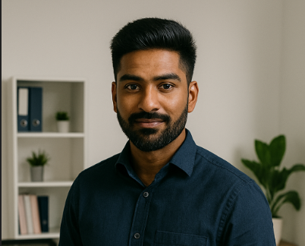  “I like staying organized and keeping things running smoothly, but I wish the system helped me cut down on the manual chaos.”  AT A GLANCE  AGE: 24  LOCATION: Kelowna, BC  LIFE STAGE: Early-career professional and MBA student  SITUATION: HR Assistant supporting TA coordination in the Faculty of Management and Education; combines part-time work with MBA studies on campus; previously worked as a TA and understands both student and staff perspectives. | MOTIVATORS  - Efficiency — Ravi wants to reduce time spent on repetitive admin tasks so he can focus on higher-level coordination.  - Dependability — He takes pride in being organized, responsive, and reliable, making sure nothing slips through the cracks.  - Growth — Working in the HR/coordination role while completing his MBA helps him gain valuable experience for future career advancement.  BEHAVIOURS  - Handles day-to-day admin — Ravi manages emails, instructor requests, and scheduling changes, often acting as the go-between for students, instructors, and the TA coordinator.  - Feels the strain of bottlenecks — When the TA coordinator is away, Ravi sometimes feels stuck, unable to move forward because key approvals or actions are locked behind others.  - Notices system gaps — Because he’s hands-on with the daily work, Ravi is keenly aware of inefficiencies in the current system and often thinks about how things could run more smoothly.  NEEDS  - A system that organizes instructor requests and student schedule changes in a clear, non-cumbersome way.  - Tools that allow Ravi to act on tasks even when the coordinator is away, reducing bottlenecks.  - Improved visibility and tracking of requests, assignments, and changes to cut down on manual follow-ups and emails.

